Task 3: SQL DML Marks: 10

1. Write down the SQL queries for the following Product Table

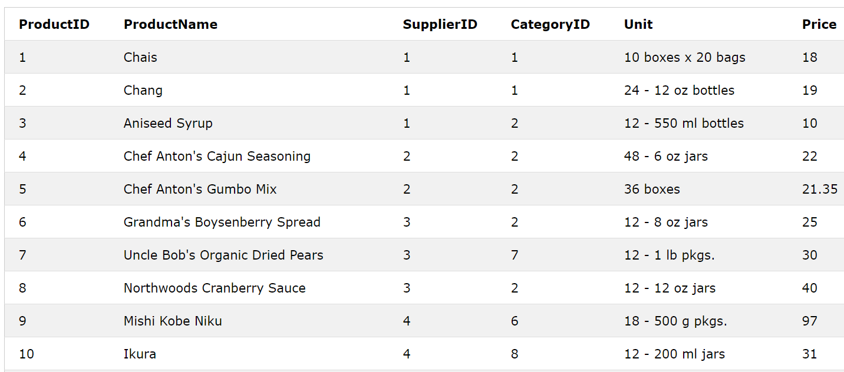

1. Create the Product Table and assign proper primary key and add a constraint that prices cannot be less than 10.
2. Find out the Minimum Price for each category of products.
3. Delete the products information for Supplier#1
4. Show the products name, supplier id and unit whose prices are less than 25.